**ReadMe file For Starting S-Interface Application**

**Steps for starting S-Interface application:**

1. **For opening in Visual Studio:**

* Open Visual Studio 2017 RC in ‘administrator’ mode and when dialog box appears click on ‘yes’.
* Go to the file menu -> open -> Open the Project/Solution.
* Open Project Properties, go to debug tab and enter the file path to S-interface.exe in the ‘Start external program’ (C:\Program Files (x86)\S-Interface\S-Interface.exe).
* Keep the Active platform as ‘x86’ and Configuration in ‘Debug’ mode.
* Keep the Target framework of Visual studio as 4.5 (.NET Framework 4.5).
* Go to Build tab and set the Output path to plugins folder in S-interface (C:\Program Files (x86)\S-Interface\Plugins\).
* Go to Solution explorer and add all the required references as shown below

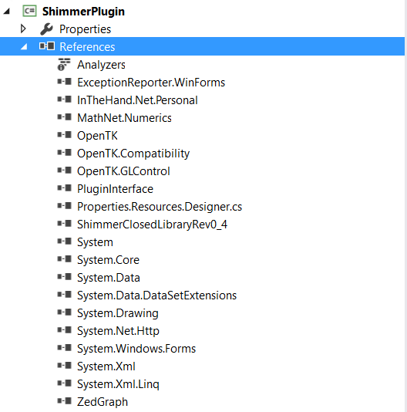

* Next add the ‘SharedAssemblyInfo.cs’ file in the properties as this project uses two different namespaces(if not already added). This file is available in (C:\Program Files (x86)\S-Interface\ShimmerPluginmostnlatest\ShimmerPlugin(1)\ShimmerPlugin\ShimmerPlugin\Properties\SharedAssemblyInfo.cs).
* Click on start and the S-Interface Application will start. Further follow the steps given below after opening the app.

1. **For starting S-Interface application .exe file directly**

* Click on S-interface.exe and run it in ‘administrator mode’.
* The S-interface application will open.
* On Plugin Graph tab click on new configuration if you want to create a new one. From the drop-down list select the Process Initiator plugin, Shimmer GSR and Real-Time Graph Plugin.
* Make the connections as shown below:

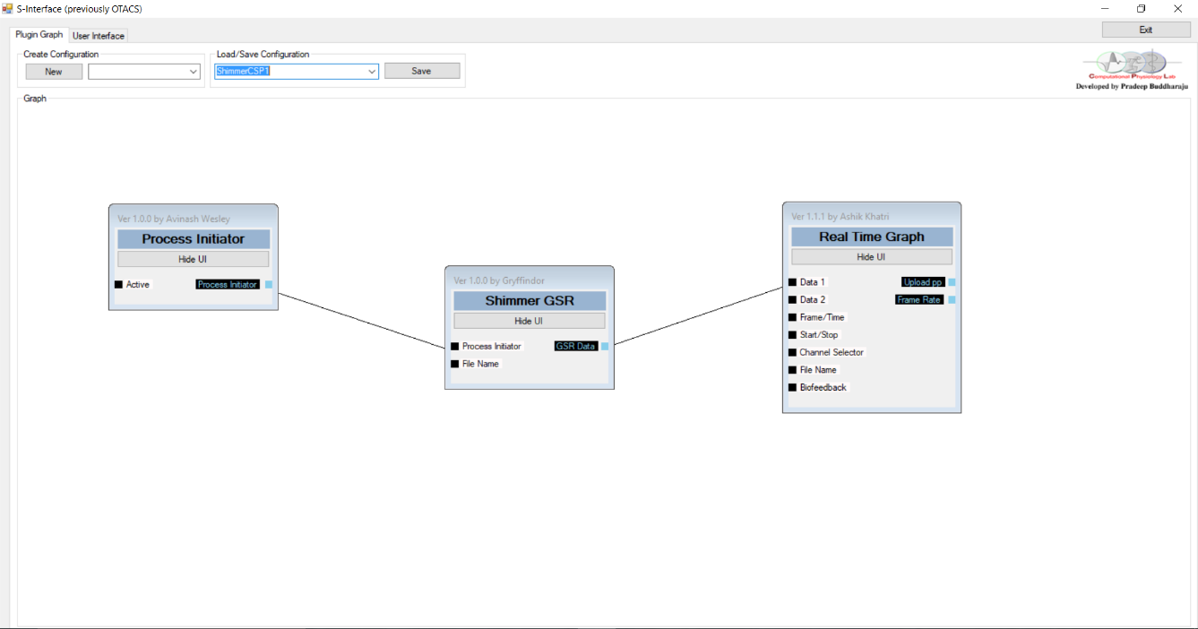

* Click on User Interface tab. Set the plugins location as desired and then click on Save. This configuration will then be saved to configurations folder in S-Interface.

OR

* The already saved configuration can also be used directly by clicking on drop-down list and selecting the configuration ‘ShimmerCSP1’.
* Go to UI tab and click on connect button for connecting with the Shimmer Device.
* Click on play button to start streaming real-time shimmer GSR data and this will be shown graphically in the Graph plugin. (Note: Make sure to wear the Shimmer Device before streaming)
* Click on Stop button to stop the streaming.
* Click on Disconnect to disconnect Shimmer device.
* Click on Exit to quit the application.